Examples of different 264_1 and 264_4 Combinations:

Both Copyright and Publication dates are listed but are different.
“This edition published in 2023” Publication date
Text © Marion Paull 2014 Copyright date
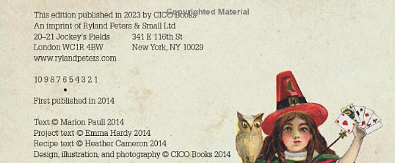
Therefore, you would need a 264 _1 with the publication date of 2023, and a 264 _4 with the copyright date of 2014.
In the Fixed Fields DtSt- you will use code t since you have two different dates, and then in Date 1 & Date 2, you will put the publication date and then the copyright date.

Only a Copyright date is listed.
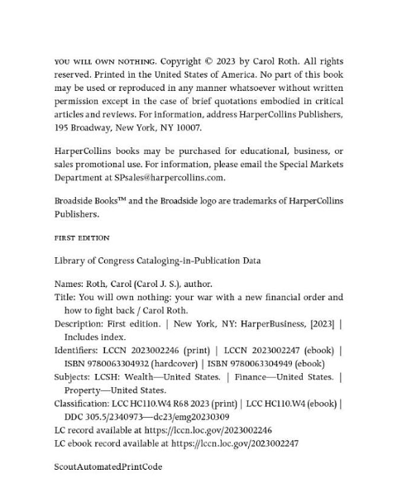
If there is only a copyright date listed, then we must assume the publication date. This is called an implied publication date.
In this instance, we will have a 264_1 with the copyright date in brackets [2023] as the implied publication date and a 264_4 with $c as the copyright date shown on the t.p. verso.
In the Fixed Fields DtSt- you will use code t since you have two dates in the 264s (implied publication date and copyright date), and then in Date 1 & Date 2, you will put the implied publication date and then the copyright date.

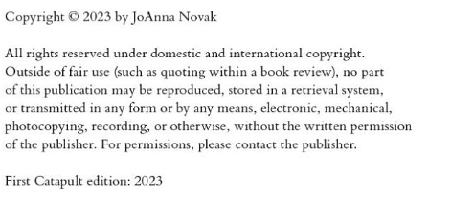
Both a copyright date and publication date are listed, but they are the same.

Since the publication date and copyright date are the same, you will only need a 264_1 with the copyright/publication date in $c. (Ex. 264 _1 $a New York :$b Catapult, $c 2023)
In the Fixed Fields DtSt – you will use code s since you only have one date in the 264 fields. You will then put the single date in Date 1.

